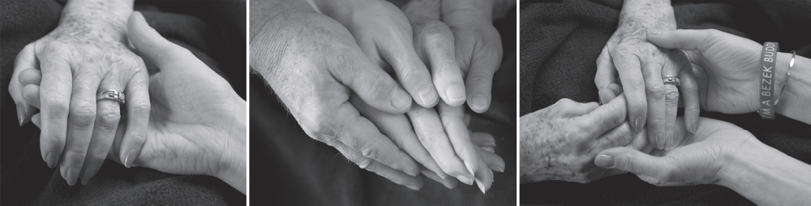

Cancer Education Wellness Series
Give It Forward: An Innovative Approach to Legacy
Presenter: Joyce Pearson, MS

Photography Shooting Techniques

- Focus on the most important subject (fingers of the patient, rings, nails)
- Hold shutter down part way to set focus, then recompose shot
- Allow other objects to be in soft focus
- Consider using dark drape
- Move in close to subjects
- Photograph in as much light as possible (window light or other room light)
- Encourage use of props (jewelry, objects of symbolic value, etc)
- Correct for lint, sleeves, chapped skin
- Be aware of fingertips, positioning of jewelry, and slant of rings
- Give guidance on natural positioning of hands and fingertips
- Consider use of tripod for sharp focus with low light
- Try a variety of perspectives and poses

Camera Tips for Photographers

- Set camera to Aperture Priority mode
- Set ISO to its highest setting (800-1600)
- Set f-stop to its widest setting (lowest number f/2.8 - f/4)
- Set camera color mode to B&W if not using post processing software
- Set Auto Focus Point to Center
- Set to Macro (flower symbol) or use Macro lens if possible
- Set built-in flash to Off position if available light is sufficient
- Make adjustments if shutter speed is slower than 1/60 sec to avoid blurring (use
tripod, flash mode, add room light as needed)

